** EAST WEST UNIVERSITY**

**Experiment No:** 02

**Course Code:** ICE470

**Course Title:** Numerical Method Lab

**Experiment Name:** Finding roots using Bisection method in the environment of MATLAB.

**Submitted To:**

Mr. Rasel Ahmmed  
 Lecturer, Department of ECE

**Submitted by:**

Md. Tariqul Islam  
**ID NO:** 2014-2-50-021

**Date of Performance**: 17.05.2018

**Date of Submission:** 24.05.2018

**Experiment No: 02**

**Experiment Name:** Finding roots using Bisection method in the environment of MATLAB.

**Objective:** **1.** To know the basic of Bisection method.

**2.** To apply this method finding different roots.

**1. Program Code :**

%Bisection Method

close all

clear all

clc

f=@(x)((667.38/x)*(1-exp(-0.146843*x)))-40;

xl=input('Enter the first approximationx1:');

xu=input('Enter the second approximationx1:');

pst=input('Enter the pre-specified tolerance:');

notier=input('Enter the maximun number of iteration:');

while(f(xl)*f(xu))>=0

xl=input('Enter the first approximationx1:');

xu=input('Enter the second approximationx1:');

end

fori=1:notier

xm=(xl+xu)/2;

xold=xm;

if (f(xl)*f(xm)<0);

xl=xl;

xu=xm;

xm=(xl+xu)/2;

else

if (f(xl)*f(xm)>0);

xl=xm;

xu=xu;

xm=(xl+xu)/2;

else

break;

end

end

e=abs((xm-xold).*100/xm);

if(i==1|| i==5 ||i==10 ||i==15 ||i==20)

fprintf('e=%f''\n',e);

end

if(e<=pst)

break;

end

end

fprintf('The root of the equation is =%f''\n',xm);

fprintf('Number of iteration =%f''\n',i);

fprintf('Approximate error is =%f''\n',e);

**command window :**

Enter the first approximationx1:1

Enter the second approximationx1:25

Enter the pre-specified tolerance:0.0001

Enter the maximun number of iteration:50

e=31.578947'

e=2.521008'

e=0.079344'

e=0.002478'

e=0.000077'

The root of the equation is =14.780209'

Number of iteration =20.000000'

Approximate error is =0.000077'

**2. Program Code 2 :**  
%% Second Part

close all

clear all

clc

x=[1 5 10 15 20];

y=[31.578947 2.521008 0.079344 0.002478 0.000077];

plot(x,y,'r*');

xlabel('Number of iteration');

ylabel('Approximate error');

fori=1:5

text(x(i),y(i),['(' num2str(x(i)),',' num2str(y(i)),')']);

end

grid on

**Figure 1 :**

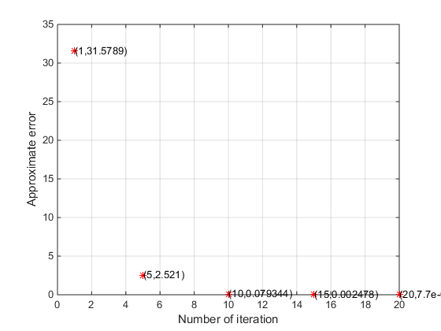

**Practice Program Code :**

%Bisection Method

close all

clear all

clc

f=@(x)((x*x)-(2*x))-15;

xl=input('Enter the first approximationx1:');

xu=input('Enter the second approximationx1:');

pst=input('Enter the pre-specified tolerance:');

notier=input('Enter the maximun number of iteration:');

while(f(xl)*f(xu))>=0

xl=input('Enter the first approximationx1:');

xu=input('Enter the second approximationx1:');

end

fori=1:notier

xm=(xl+xu)/2;

xold=xm;

if (f(xl)*f(xm)<0);

xl=xl;

xu=xm;

xm=(xl+xu)/2;

else

if (f(xl)*f(xm)>0);

xl=xm;

xu=xu;

xm=(xl+xu)/2;

else

break;

end

end

e=abs((xm-xold).*100/xm);

if(i==1|| i==5 ||i==10 ||i==15 ||i==20)

fprintf('e=%f''\n',e);

end

if(e<=pst)

break;

end

end

fprintf('The root of the equation is =%f''\n',xm);

fprintf('Number of iteration =%f''\n',i);

fprintf('Approximate error is =%f''\n',e);

**Command window :**

Enter the first approximationx1:-10

Enter the second approximationx1:1

Enter the pre-specified tolerance:0

Enter the maximun number of iteration:50

e=157.142857'

e=5.820106'

e=0.178949'

e=0.005595'

e=0.000175'

The root of the equation is =-3.000000'

Number of iteration =50.000000'

Approximate error is =0.000000'

**Command window :**

Enter the first approximationx1:1

Enter the second approximationx1:25

Enter the pre-specified tolerance:0

Enter the maximun number of iteration:50

e=85.714286'

e=7.317073'

e=0.234558'

e=0.007324'

e=0.000229'

The root of the equation is =5.000000'

Number of iteration =50.000000'

Approximate error is =0.000000'

**Discussion :** This experiment is done by using Bisection method in MATLAB. The name of the experiment Finding roots using Bisection method in the environment of MATLAB. Bisection method separate intervals and select a sub-interval in which root of the equation lies. There are two program codes. The equation is given in the code by which i have to perform the code. Plot command use to plot the graph of the given equation. Both the program code are same. For the last one program code aprroximate error is zero. Here input is used as a user input which means I have to give the value as a user. So I have to give the value of first approximationx1, second approximationx1, pre-specified tolerance, maximun number of iteration. fprintf function is used for printing information to the screen, that means which will show the result in the command window. The grid on adds major grid lines to the current axes. While doing this program code I got some error and firstly I didnt geet the perfect result. Then I have to perform it correctly to get the approximate error 0.000000. For this, I had to take the tolerance 0 and different first approximation and second approximation.The program code 2 has the values of x, y. Here, x-label is for number of iteration and y-label is for approximate error. The grid on adds major grid lines to the current axes. After writing the correct code, I got the figure 1. It was difficult to perform because I made some error while doing this codes. Have to attentive while donig those codes and have to know about bisection method correctly.